INTERNSHIP REPORT

ON

“FINANCIAL DATA ANALYSIS AND EXPENSE TRACKING SYSTEM”

Submitted to
SAVITRIBAI PHULE PUNE UNIVERSITY

In Partial Fulfillment of the Requirement for the Award of

T.E. COMPUTER ENGINEERING
SEMESTER VI

SUBMITTED BY

Student Full Name: ISHAM ACHYUT SINGH Exam No.:

Under the Guidance of
Prof. Niketa Mahajan



DEPARTMENT OF COMPUTER ENGINEERING
ALARD COLLEGE OF ENGINEERING AND MANAGEMENT
MARUNJI, PUNE-57
(AFFILIATED TO SAVITRIBAI PHULE PUNE UNIVERSITY)
2024 – 2025


CERTIFICATE

This is to certify that the Internship report entitles

“FINANCIAL DATA ANALYSIS AND EXPENSE TRACKING SYSTEM”

Submitted by

Student Full Name: ISHAM ACHYUT SINGH Exam No.:

Is a bonafide student of this institutes and the work has been carried out by him/her under the supervision of Prof. Niketa Mahajan and it is approved for the partial fulfillment of the requirement of Savitribai Phule Pune University, for the T.E. Computer Engineering.

Prof. Niketa Mahajan Prof. Dipali Mane

Dept. of Computer Engg. Dept. of Computer Engg.

Place: Pune
Date:
Acknowledgement

It is our privilege to express our sincerest regards to our class teacher, Prof. Niketa Mahajan, for her valuable inputs, able guidance, encouragement, whole-hearted cooperation and constructive criticism throughout the duration of our Internship.
We deeply express our sincere thanks to our Head of Department Prof. Dipali Mane for encouraging and allowing us to present the audit course on the topic “FINANCIAL DATA ANALYSIS AND EXPENSE TRACKING SYSTEM” at our department premises for the partial fulfillment of the requirements of T.E. Computer Engineering.
Abstract

In an increasingly complex economic environment, personal financial management is critical for students and young professionals. This project focuses on the end-to-end data engineering, analysis, and visualization of a simulated personal finance profile for a resident in Pune, India.
The project utilizes a Python-based script to programmatically generate a realistic dataset comprising an entire year's worth of daily transactional data. This dataset includes fixed monthly incomes and highly variable daily expenses categorized into Food, Transport, Rent, Subscriptions, Education, and Entertainment. Following the data generation, a hidden-angle strategic analysis is conducted to evaluate baseline savings and project the financial impact of specific behavioral and career changes (a 15% salary hike coupled with a 10% reduction in spending). Finally, the data is prepared for import into Microsoft Power BI to create an interactive Business Intelligence dashboard, enabling dynamic exploratory data analysis.

Table of Contents

Sr. No. | Topic | Page No.
1 | Introduction
2 | Methodology and Tools
3 | Data Dictionary and Schema
4 | Strategic Financial Analysis
5 | Business Intelligence (Power BI)
6 | Insights and Recommendations
7 | Conclusion
8 | Future Enhancements
9 | Appendices

1.Introduction

1.1 Background and Motivation
As a 3rd-year computer engineering student, the intersection of data and daily life presents a unique opportunity for optimization. Traditional budgeting methods (manual diaries or simple apps) often lack the ability to perform "What-If" simulations. The motivation for this project was to bridge the gap between Static Tracking and Predictive Planning.

  - Project Objectives
- Architecting a Synthetic Data Pipeline: Using Python to simulate human-like spending behavior.
- Behavioral Modeling: Quantifying the "Hidden Angle"—how minor changes in lifestyle (10% reduction) and career (15% hike) compound.
- Visual Intelligence: Creating a dashboard that allows for "Drill-Down" analysis into specific expense categories.

1.3 Scope of the Project
The project covers data generation (Python), data cleaning (Pandas), exploratory analysis (Matplotlib/Seaborn logic), and final visualization (Power BI). It focuses specifically on a single-user profile over a 12-month fiscal period (2025).

2. Methodology and Tools

2.1 Technology Stacks

Python 3.x: Used as the primary engine for data generation and backend analysis.

Pandas Library: Employed for data structuring, handling missing values (though none in this synthetic set), and exporting to CSV.

Microsoft Power BI: Used for the Business Intelligence layer, utilizing DAX (Data Analysis Expressions) for real-time calculations.

2.2 Data Generation Strategy (Python)

The dataset is generated using a custom Python function generate_data(). To ensure the data mimics real-life behavior, several statistical rules and constraints were hardcoded into the generation loop:

Temporal Distribution: Transactions are distributed across the year 2025. The script utilizes the timedelta function combined with a random integer between 0 and 364 to assign a specific date to each of the 300 expense transactions.

Categorical Weights: Expenses are randomly assigned to one of six categories: Food, Transport, Rent, Subscriptions, Education, and Entertainment.

Realistic Pricing Bounds:

Rent: Fixed at ₹8,500 per transaction, reflecting average shared accommodation costs.

Food: Highly variable, bounded between ₹100 and ₹500 per transaction.

Transport: Bounded between ₹50 and ₹1,000, representing a mix of daily commutes and occasional longer travel.

Other Categories: General expenses bounded between ₹200 and ₹2,000.

Income Injection: A secondary loop guarantees exactly one income transaction ("Allowance/Salary") of ₹25,000 on the 1st of every month

2.3 Assumptions and Constraints

The simulation assumes a strict, localized economy (Pune). It assumes no major emergencies (e.g., medical bills over ₹2,000) and assumes a perfectly consistent monthly income with no unpaid leave or bonuses in the baseline model.

3. Data Dictionary and Schema

3.1 The generated dataset, financial_data.csv, follows a flat, denormalized schema suitable for immediate BI ingestion.

Column Name | Data Type | Description | Example
Date | Date(YYYY-MM-DD) | The exact data the transaction occurred | 25-04-14
Category | String | The classification of the transaction (e.g., Food , Rent, ) | Entertainment
Amount | Integer | The monetary value of the transaction in INR | 824
Type | String | Identifies if the transaction is an “income” or an “expense” | Expense

4. Strategic Financial Analysis

4.1 Baseline Financial Health

Upon generating the data, the run_analysis(df) function evaluates the baseline.

Total Income: Calculated by summing the 'Amount' where 'Type' equals 'Income'. (Standard: ₹300,000 annually).

Total Expense: Calculated by summing the 'Amount' where 'Type' equals 'Expense'.

Net Savings: The absolute difference between Total Income and Total Expense.

If the Net Savings are close to zero or negative, the simulated user is living paycheck-to-paycheck or accumulating debt.

4.2 The "Hidden Angle" Scenario Analysis

The core analytical feature of this project is the "What-If" scenario. Personal finance is heavily influenced by compounding habits. The script applies two strategic adjustments:

Salary Hike (15%): Simulating a career promotion or a switch to a better-paying job.

Spending Reduction (10%): Simulating a conscious effort to budget, cut unnecessary subscriptions, and reduce discretionary spending (like dining out or entertainment).

4.3 Mathematical Projections

The script utilizes the following formulas to project the new financial reality:

Projected Income = Total_Income * 1.15

Projected_Expense = Total_Expense * 0.90

New_Savings = Projected_Income - Projected_Expense

By presenting the "Annual Improvement" and the "Projected Monthly Savings", the user is given an actionable, motivational target, bridging the gap between raw data and financial planning.

5. Business Intelligence and Visualization (Power BI)

5.1. Data Import and Transformation
- The financial_data.csv is imported into Power BI using the standard Get Data -> Text/CSV connector. During the Power Query phase, the following transformations are recommended:
- Verify the Amount column is set to a Fixed Decimal Number (Currency).
- Verify the Date column is recognized as a Date type to enable Power BI's automatic Time Intelligence features.
5.2. Key Performance Indicators (KPIs)
- At the top of the dashboard, Card visuals should be used to display:
- Total Income (YTD)
- Total Expenses (YTD)
- Savings Margin (%) - (Calculated as [Total Income - Total Expenses] / Total Income)
5.3. Proposed Dashboard Visuals
- Visual 1: Expenses by Category (Donut Chart or Bar Chart)
- Purpose: To identify the largest cash drains. Rent is expected to be the largest, but visualizing the proportion of "Entertainment" vs "Food" helps target the 10% spending reduction goal.
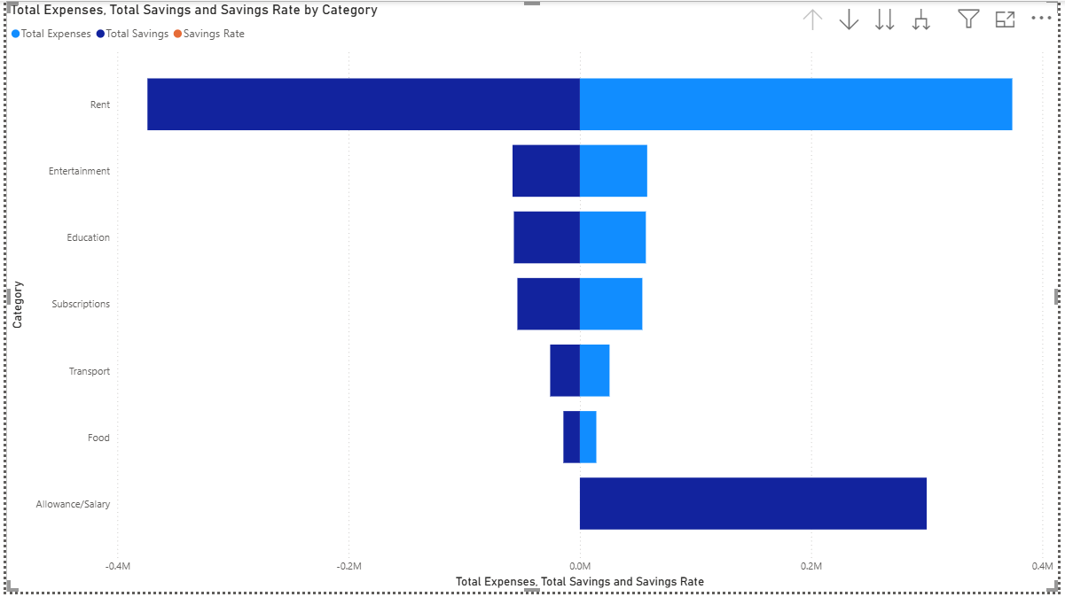

- Visual 2: Income vs. Expense over Time (Line and Clustered Column Chart)
- Purpose: To track the burn rate throughout the year. The X-axis represents the Months, the Column represents Expenses, and the Line represents Income.
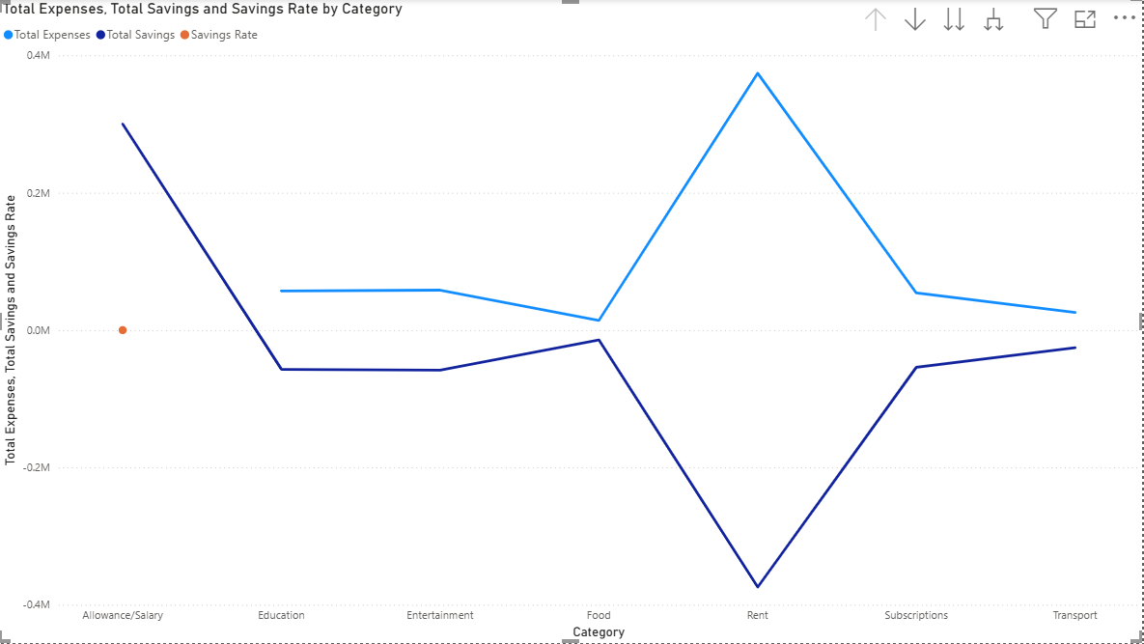
- Visual 3: Transaction Frequency (Treemap)
- Purpose: While Rent is high-cost, Food and Transport are high-frequency. A treemap showing the count of transactions per category highlights daily behavioral habits.
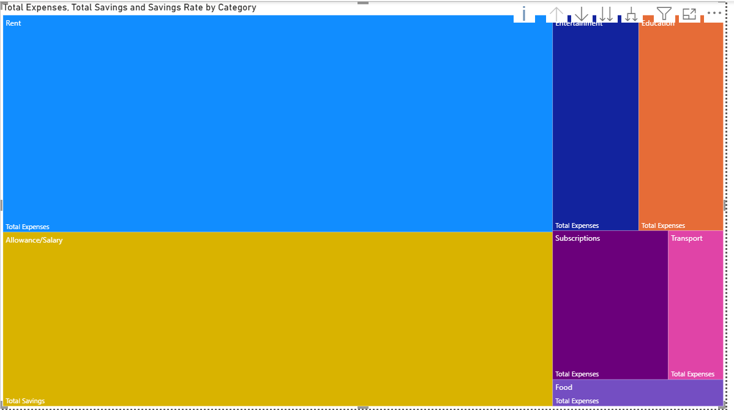

6.Insights and Recommendations

Based on the simulated data and the strategic what-if analysis, several actionable recommendations can be made for the profile subject:
- Target High-Frequency Spending: While Rent is fixed at ₹8,500, daily micro-transactions in 'Food' and 'Transport' compound rapidly. To achieve the 10% overall expense reduction modeled in the Python script, the subject should focus on meal-prepping and utilizing public transit passes.
- Optimize Subscriptions: The data reveals scattered subscription charges. Consolidating digital subscriptions (streaming services, software) can immediately free up monthly cash flow with zero impact on career growth.
- Leverage the 15% Hike: The analysis shows that a 15% increase in income paired with a 10% decrease in expenses drastically multiplies total savings. The subject should aggressively upskill in their current role or negotiate their allowance/salary at the end of the fiscal year.

7.Conclusion

This project successfully demonstrates the entire lifecycle of personal financial analytics. By utilizing Python and Pandas, we bypassed the tedious process of manual data entry, programmatically generating a robust dataset that mimics human economic behavior. The built-in strategic analysis algorithm proves that combining minor frugal habits with career progression yields exponential financial growth.
Furthermore, by integrating this dataset with Microsoft Power BI, raw numbers are transformed into an interactive, visual narrative. This allows users to drill down into specific months or categories, fundamentally changing how personal budgeting is approached—moving from reactive tracking to proactive wealth management.

8. Future Enhancements

To scale this project further, the following technical and analytical enhancements are proposed:
- Database Integration: Transitioning from a flat .csv file to an SQLite or MySQL database using SQLAlchemy.
- Machine Learning Forecasting: Implementing an ARIMA (AutoRegressive Integrated Moving Average) model or Facebook Prophet in Python to predict future expenses based on the current year's trend.
- Real-Time Data Pipelines: Creating a secure API webhook to pull actual bank transaction data rather than using randomized simulated data.
- Dynamic Power BI Parameters: Replicating the Python "What-If" scenario directly inside Power BI using "What-If Parameters" (DAX), allowing the end-user to use a slider to adjust salary hikes and expense reductions on the fly.

9. Appendices

9.1 Appendix A: Python Source Code
- Below is the core Python script used to generate the data and run the backend analysis.
import pandas as pd
import random
from datetime import datetime, timedelta

def generate_data(filename='financial_data.csv'):
categories = ['Food', 'Transport', 'Rent', 'Subscriptions', 'Education', 'Entertainment']
data = []
start_date = datetime(2025, 1, 1)

for i in range(300):
date = start_date + timedelta(days=random.randint(0, 364))
category = random.choice(categories)
transaction_type = "Expense"

if category == 'Rent': amount = 8500
elif category == 'Food': amount = random.randint(100, 500)
elif category == 'Transport': amount = random.randint(50, 1000)
else: amount = random.randint(200, 2000)

data.append([date.strftime('%Y-%m-%d'), category, amount, transaction_type])

for month in range(1, 13):
data.append([f"2025-{month:02d}-01", "Allowance/Salary", 25000, "Income"])

df = pd.DataFrame(data, columns=['Date', 'Category', 'Amount', 'Type'])
df.to_csv(filename, index=False)
return df

def run_analysis(df):
total_income = df[df['Type'] == 'Income']['Amount'].sum()
total_expense = df[df['Type'] == 'Expense']['Amount'].sum()
savings = total_income - total_expense

SALARY_HIKE_PERCENTAGE = 15
SPENDING_REDUCTION_PERCENTAGE = 10

projected_income = total_income * (1 + SALARY_HIKE_PERCENTAGE / 100)
projected_expense = total_expense * (1 - SPENDING_REDUCTION_PERCENTAGE / 100)
new_savings = projected_income - projected_expense

print(f"Projected Monthly Savings: ₹{new_savings/12:,.2f}")
print(f"Annual Improvement: ₹{new_savings - savings:,.2f}")

if __name__ == "__main__":
financial_df = generate_data()
run_analysis(financial_df)

9.2. Appendix B: Sample Dataset snippet (financial_data.csv)

Date | Category | Amount | Type
25-10-03 | Subscription | 456 | Expense
2025-12-29 | Education | 1060 | Expense
2025-12-09 | Rent | 8500 | Expense
2025-01-01 | Allowance/salary | 25000 | Income
2025-02-01 | Allowance/salary | 25000 | Income

